ANOVA Analysis of Supply Chain Efficiency and Product Quality
STAT 301 Group Project | Feifei Li, Kateryn Stoven

Introduction
This project analyzes a supply chain dataset containing 100 observations and 24 variables, obtained from Kaggle, documenting operational and quality metrics across a consumer goods supply chain in five Indian cities. Two research questions are examined: (1) Does product type significantly affect manufacturing costs? (2) Do transportation mode and product type interact to affect defect rates?
The four variables used are:
IV 1: Product Type, a categorical independent variable with 3 levels (cosmetics n=26, haircare n=34, skincare n=40), serving as the independent variable in both questions.
IV 2: Transportation Mode, a categorical independent variable with 4 levels (Air n=26, Rail n=28, Road n=29, Sea n=17), is the second independent variable in Question 2.
DV 1: Manufacturing Costs, a continuous numeric dependent variable representing total production cost per SKU in dollars, is the response variable for Question 1.
DV 2: Defect Rates, a continuous numeric dependent variable representing the proportion of defective units per SKU, is the response variable for Question 2.
Question 1 hypotheses:
H₀: μ₁ = μ₂ = μ₃.
H₁: At least two means of product type are different.
Question 2 hypotheses:
- main effects of transportation mode
H₀: µ_{AIR} = µ _{RAIL} = µ_{Road} = µ _{Sea}
H₁: at least two means are different.
- Main Effects of Product type
H₀: µ _{haircare} = µ_{cosmetics} = µ _{skincare}
H₁: at least two means are different
- Interaction between transportation mode and product type.
H₀: There is no interaction between transportation mode and product type;
H₁: There is an interaction between transportation mode and product type.

Methods

Data Cleaning and Processing

The dataset was imported into R from the original Kaggle CSV. Four ambiguous column names were renamed (e.g., Lead.times → Supplier_Lead_Time, Costs → Total_Costs). No missing values and no duplicate rows were found. All categorical variables were converted to R factors. An IQR-based outlier scan identified no extreme values. All 100 observations and 24 variables were retained in the cleaned dataset Cleaned_Supply_Chain_Data.

Choice of Analysis
Question 1 uses a one-way ANOVA because there is one categorical IV (Product Type, 3 levels) and one continuous DV (Manufacturing Costs). ANOVA is chosen over multiple pairwise t-tests because running three t-tests at α = 0.05 inflates the Type I error rate. ANOVA controls this with a single F-test (F = MSB / MSW).
Question 2 uses a two-way ANOVA with interaction because there are two categorical IVs (Transportation Mode and Product Type) and one continuous DV (Defect Rates). The 4×3 design is unbalanced (see Table 2), so Type II sums of squares are applied via the Anova() function from the car package, which is order-independent and appropriate for unbalanced designs. When the interaction is significant, post-hoc analysis is conducted within the transportation mode where the interaction appears strongest.

Conclusion

Question 1: One-Way ANOVA — Product Type vs. Manufacturing Costs
Table 1: One-Way ANOVA Results — Manufacturing Costs by Product Type
Source | df | Sum Sq | Mean Sq | F value | p-value
Product Type | 2 | 629.0 | 314.6 | 0.370 | 0.692
Residuals | 97 | 82531.0 | 850.8 | — | —
Note: α = 0.05. ns = not significant.
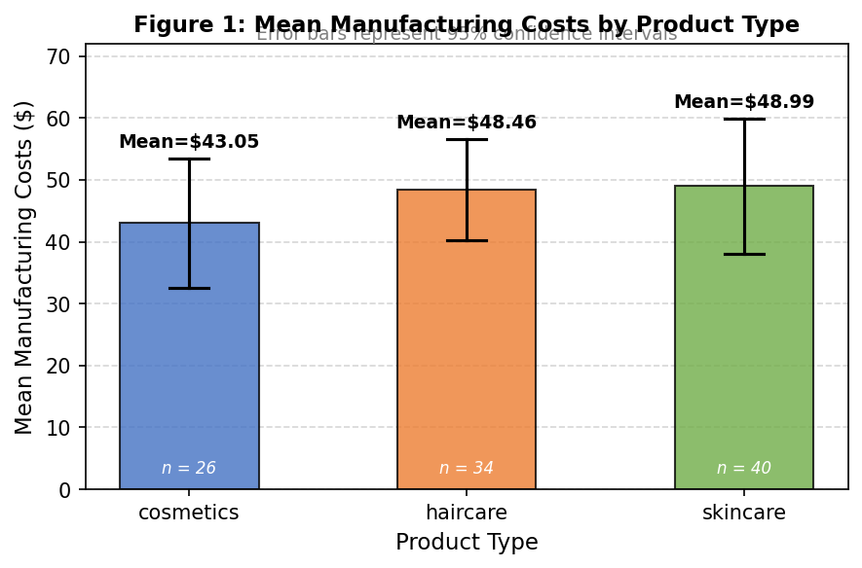
Figure 1: Mean Manufacturing Costs by Product Type with 95% CIs. Mean values labeled above error bars.
Test statistic: F = 0.370, p = 0.692.
Since p = 0.692 > 0.05, we fail to reject H₀. There is no statistically significant difference in mean manufacturing costs across product types; No post-hoc testing is needed.

Question 2: Two-Way ANOVA — Transportation Mode × Product Type vs. Defect Rates
Table 2 confirms the unbalanced cell structure requiring Type II SS. Table 3 presents the full ANOVA results. Figure 2 shows the interaction plot.
Table 2: Cell Counts — Transportation Mode × Product Type
Transport Mode | Cosmetics | Haircare | Skincare | Total
Air | 5 | 8 | 13 | 26
Rail | 9 | 10 | 9 | 28
Road | 6 | 12 | 11 | 29
Sea | 6 | 4 | 7 | 17
Total | 26 | 34 | 40 | 100
Note: Cell sizes range from 4 to 13 — unbalanced design requiring Type II SS.
Table 3: Two-Way ANOVA (Type II SS) — Defect Rates by Transportation Mode and Product Type
Source | df | Sum Sq | F value | p-value | Significance
Transportation Mode | 3 | 9.07 | 1.61 | 0.193 | ns
Product Type | 2 | 5.13 | 1.37 | 0.261 | ns
Mode × Type (Interaction) | 6 | 32.00 | 2.84 | 0.014 | * sig.
Residuals | 88 | 165.45 | — | — | —
Note: ns = not significant; * = significant at α = 0.05.
Decision
Transportation Mode: F = 1.61, p-value = 0.193 > 0.05 → fail to reject H0
Product Type: F = 1.37, p-value = 0.261 > 0.05 → fail to reject H0
Interaction: F = 2.84, p-vaule = 0.014 < 0.05 → REJECT H₀,
There is significant interaction between Transportation. Mode with Product. Type

Figure 2: Interaction Plot — Mean Defect Rate by Transportation Mode and Product Type. Lines diverge sharply under Air (cosmetics ~0.40 vs. haircare ~2.92), confirming the significant interaction (p = 0.014). 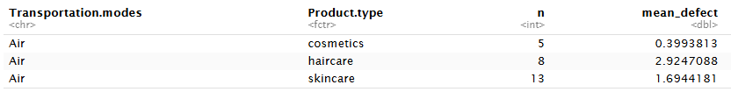
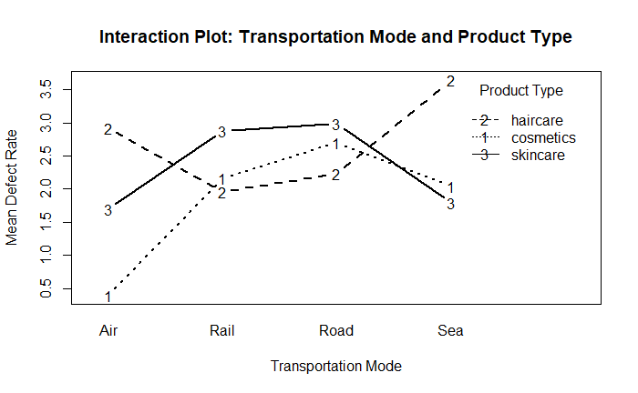
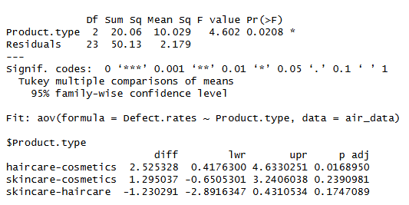
Post-hoc Analysis: Because the interaction plot shows the strongest divergence under Air transportation (cosmetics mean defect rate ~0.40 vs. haircare ~2.92), we conducted one-way ANOVA within Air mode only. Results showed a significant effect of product type under Air (F = 4.602, p-value = 0.021). Tukey HSD confirmed that haircare products have significantly higher defect rates than cosmetics under Air transportation (difference = +2.525, adjusted p = 0.017). No significant differences were found between skincare and either group. For Rail, Road, and Sea modes, the lines are roughly parallel, suggesting no meaningful product-type differences within those transportation modes.

Most Interesting Finding
The most compelling result is the contrast between the two questions. Product type alone does not affect manufacturing costs (p-value = 0.692), and transportation mode alone does not affect defect rates (p-value = 0.193) — yet their combination reveals a significant quality difference (p-value= 0.014). This demonstrates the importance of examining interaction effects. From a management perspective, air transportation should be used with caution for haircare products, and uniform logistics policies applied across all product types may conceal important quality risks.

Limitations
Sample size. With n = 100 across 24 cells, cell sizes range from 4 to 13 observations. The smallest cell (Sea + Haircare, n = 4) reduces statistical power and increases uncertainty in cell-level estimates.
Observational data. The dataset is not experimental; causality cannot be established. Confounders such as shipping distance or packaging quality may explain the interaction.
Generalizability. Results reflect one supply chain in India and may not transfer to other industries or regions.

References
Amirmotefaker. (n.d.). Supply chain analysis [Kaggle notebook]. Retrieved from https://www.kaggle.com/code/amirmotefaker/supply-chain-analysis/input

